Tab 1
Ideas
- Extend the timeline of data from 2022 onwards for Goyal and Welch paper
- Machine learning 2020 paper, change a country
- FX
- Predict crypto price - variables
https://www.sciencedirect.com/science/article/abs/pii/S0952197624001490

Predicting daily returns of USDJPY
timeline: predict on high frequency?? (e.g. next min, next hour)/daily/monthly?
predicting: absolute value, returns (simple return, log return)
baseline model: random walk, use today’s value to predict tmr??/ mean, e.g. 0 for change
possible predictors:
  - interest rate differential (e.g. JGB 2y bond yield and US 2y bond yield → affected by central bank, JGB 10y bond yield and US 10y bond yield → affected by market)
  - stock market performance (e.g. SPX vs NKY) → can engineer some features like % return, ratio of % returns etc.
  - other macro factors (e.g. CPI, FDI)
  - lagged features (e.g. yesterday’s price, yesterday’s return, etc.)
  - moving averages (e.g. 5 days MA, 12 days MA, etc.)
  - technical indicators (e.g. Bollinger band, relative strength index, MACD, etc.)

data available
- JGB 10Y yield (monthly) since 1989 from FRED https://fred.stlouisfed.org/series/IRLTLT01JPM156N
- NIKKEI 225 close data (daily) since 1949 from FRED
https://fred.stlouisfed.org/series/NIKKEI225
- S&P 500 close data (daily) since 2015 from FRED
https://fred.stlouisfed.org/series/SP500
- Japan CPI (monthly) since 1999 from FRED
https://fred.stlouisfed.org/series/JPNCPIALLMINMEI
- US 2Y yield (daily) since 1976 from FRED
https://fred.stlouisfed.org/series/DGS2
- Almost any US interest rate data from FRED
https://fred.stlouisfed.org/categories/22
- USDJPY spot rate from BOJ
https://www.stat-search.boj.or.jp/ssi/mtshtml/fm08_d_1_en.html
Technical indicators can be engineered from prices

Missing:
- JGB 2Y yield

Qns:
- Some data are available on a daily basis whereas others only available on a monthly basis, is it problematic to fill the monthly data to daily??
- Is daily data enough?

Relevant Paper
https://www.sciencedirect.com/science/article/pii/S2666827025000313
https://docs.neu.edu.tr/library/6721800683.pdf
https://www.sciencedirect.com/science/article/pii/S0957417424004032#s0045

Goyal and Welch 2022
- Macroeconomic:
  - CP ogap
    - Cooper and Priestley (RFS 2009), » Time-Varying Risk Premiums and the Output Gap
    - output gap of industrial production
    - (1926:01 - 2021:12)
  - JT ndrbl (monthly)
    - Jones and Tuzel (RFS 2013), » New Orders and Asset Prices
    - new orders to shipments of durable goods
    - (1958:02 - 2021:12)
  - AMP pce
  - BY govik
  - CGP crdstd (quarterly)
  - CGMS skew (semiannual)
  - MR gpce (and gip)
  - PST house (annual).
- Sentiment
  - HJTZ sntm
  - Maio ygap
  - RRZ shtint (monthly)
  - HHT accrul (and cfacc, annual).
- 3. Variance-Related
  - BH vp
  - BPS impvar
  - BTZ vrp
  - Mrtn rsvix (all monthly).
- 4. Stock Cross-Section
  - CEP lzrt
  - JZZ skvw
  - KJ tail
  - KP fbm
  - Maio rdsp
  - PW avgcor (all monthly).
- 5. Other Stock Market: NRTZ tchi, LY dtoy (and dtoat), and Yu disag (all monthly);
- 6. Commodities: DJM wtexas (monthly).

2024

Local Predictors (country-level)
- Valuation ratios: Dividend-price ratio (DP), Earnings-price ratio (EP), Book-to-market (BM)
- Yield variables: Short rate, term spread, default spread
- Return-based variables: Lagged return, volatility measures
Global Predictors
- Global DP / EP ratios (aggregated across countries)
- Global interest rate variables (term spread, short rate, credit spreads)
- U.S. predictors (used as global benchmarks, since U.S. markets are influential)
- Global risk factors (volatility indices, commodity prices, FX conditions)
2012
Macroeconomic: dividend–price ratio, earnings–price ratio, book-to-market ratio, net equity expansion, Treasury bill rate, long-term yield, long-term return, term spread, default yield spread, default return spread, stock variance, inflation, stock turnover, consumption–wealth ratio,
Technical: 12-month moving average, 9-month moving average, 6-month moving average, 3-month moving average, momentum (12-month cumulative return), short-term reversal (1-month return), relative strength index, on-balance volume, detrended price oscillator, trading volume, advance–decline ratio, and net new highs.

Goyal and Welch 2022
Link to Paper: https://academic.oup.com/rfs/article/37/11/3490/7749383?login=false
Citations: https://www.webofscience.com/wos/woscc/summary/6c98fc78-7251-498e-bebf-c118050094eb-0179ae1993/date-descending/1

Raw Data
- Amit Goyal’s website: https://sites.google.com/view/agoyal145
- Available datasets from Amit Goyal’s website, vintage data up to 2024: https://drive.google.com/file/d/166AbyiYLq60JpZX7yYo8RRGggFktLeKP/view?usp=sharing
- 2024 full sample data: https://docs.google.com/spreadsheets/d/10_nkOkJPvq4eZgNl-1ys63PzhbnM3S2y/edit?gid=1060486139#gid=1060486139

Data Summary
Goyal and Welch 2022 Data Summary
- 29 variables from 26 papers published after Goyal and Welch 2008 → data available
  - Available datasets from Amit Goyal’s website, vintage data up to 2024: https://drive.google.com/file/d/166AbyiYLq60JpZX7yYo8RRGggFktLeKP/view?usp=sharing
- 17 original variables in Goyal and Welch 2008 → cannot find vintage data, only data in 2024

ML 2020
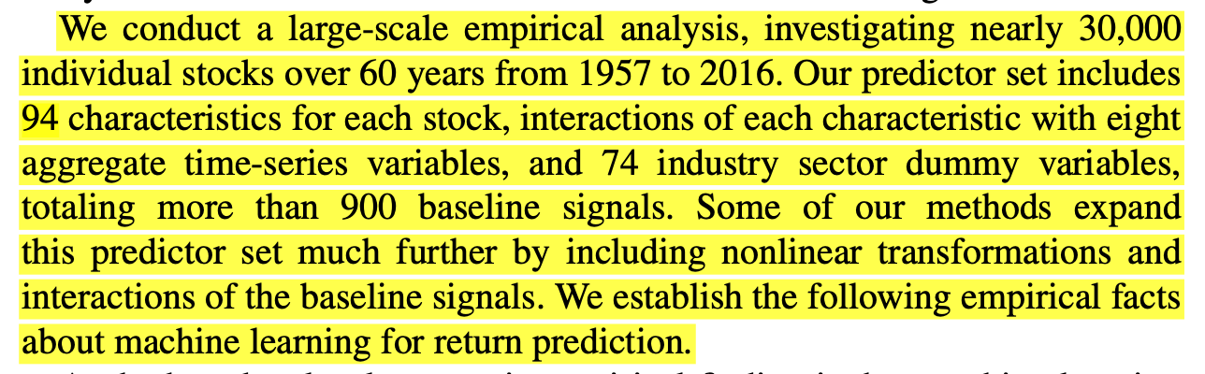

These 94 predictors are only limited to US stock market. Examples:
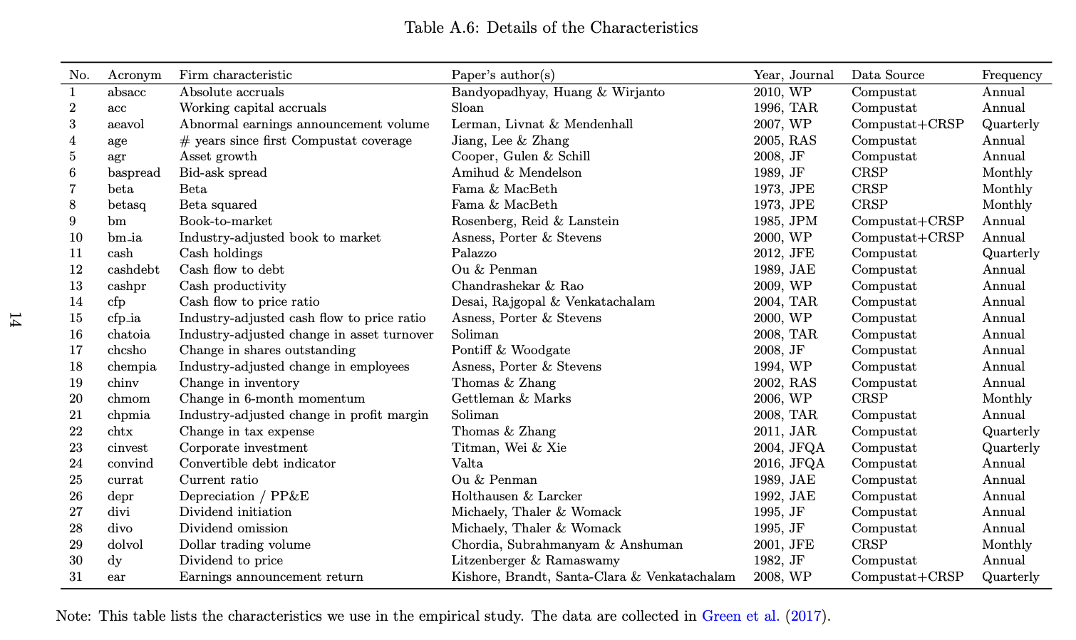
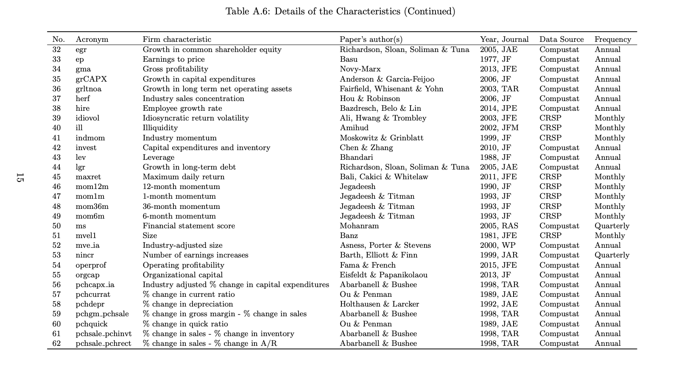
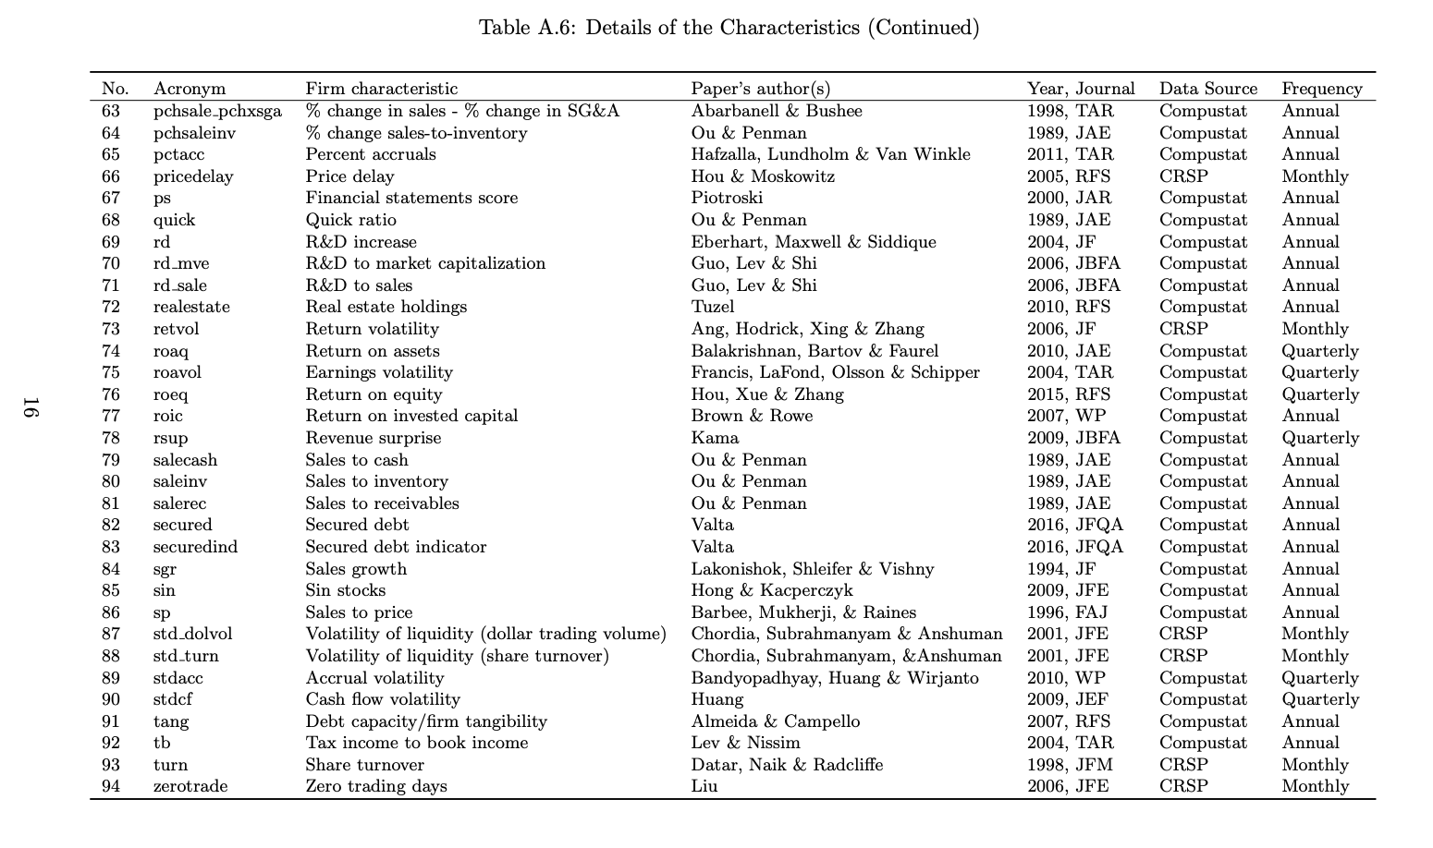

USD/JPY Fx
Predicting daily returns of USDJPY
- timeline: predict on high frequency?? (e.g. next min, next hour)/daily/monthly?
- predicting: absolute value, returns (simple return, log return)
- baseline model: random walk, use today’s value to predict tmr??/ mean, e.g. 0 for change

possible predictors:
  - interest rate differential (e.g. JGB 2y bond yield and US 2y bond yield → affected by central bank, JGB 10y bond yield and US 10y bond yield → affected by market)
  - stock market performance (e.g. SPX vs NKY) → can engineer some features like % return, ratio of % returns etc.
    - order flow, bid-ask spreads, liquidity measures
  - other macro factors (e.g. CPI, FDI)
  - lagged features (e.g. yesterday’s price, yesterday’s return, etc.)
  - moving averages (e.g. 5 days MA, 12 days MA, etc.)
  - technical indicators (e.g. Bollinger band, relative strength index, MACD, etc.)

data available
- JGB 10Y yield (monthly) since 1989 from FRED https://fred.stlouisfed.org/series/IRLTLT01JPM156N
- NIKKEI 225 close data (daily) since 1949 from FRED
https://fred.stlouisfed.org/series/NIKKEI225
- S&P 500 close data (daily) since 2015 from FRED
https://fred.stlouisfed.org/series/SP500
- Japan CPI (monthly) since 1999 from FRED
https://fred.stlouisfed.org/series/JPNCPIALLMINMEI
- US 2Y yield (daily) since 1976 from FRED
https://fred.stlouisfed.org/series/DGS2
- Almost any US interest rate data from FRED
https://fred.stlouisfed.org/categories/22
- USDJPY spot rate from BOJ
https://www.stat-search.boj.or.jp/ssi/mtshtml/fm08_d_1_en.html
DXY
Technical indicators can be engineered from prices

Missing:
- JGB 2Y yield

Qns:
- Some data are available on a daily basis whereas others only available on a monthly basis, is it problematic to fill the monthly data to daily??
  - Are we really aiming for a long-term prediction? Since fx market can be highly efficient, many papers have actually found random walk hard to beat. Maybe we can focus on high frequency only.
- Is daily data enough?
- Are we trying to forecast it from a trading perspective or an accuracy perspective? +- prediction might already be efficient to advise on buy/sell.

Relevant Paper
https://www.sciencedirect.com/science/article/pii/S2666827025000313
https://docs.neu.edu.tr/library/6721800683.pdf
https://www.sciencedirect.com/science/article/pii/S0957417424004032#s0045

The Predictability of the Exchange Rate When Combining Machine Learning and Fundamental Models : this paper combined the traditional economic models that we learnt with machine learning models. quite interesting. also th
lis: Fundamentals and exchange rate forecastability with simple machine learning methods - ScienceDirect

Predicting FX market movements using GAN with limit order event data: can refer to this article for the data on market order, limit order, and liquidity

Variable Name | Data Source | Remark
Return |  | Target Variable

Scopus - Document Details

Project Proposal
Project Proposal
The foreign exchange (FX) market is the world’s largest and most liquid financial market. Accurate forecasts of exchange rate movements help market participants manage risk and make informed decisions. This project studies USD/JPY daily return prediction using both traditional statistical models (OLS, Ridge, LASSO, PCA variants) and tree-based machine learning methods (Random Forests, Gradient Boosted Trees such as XGBoost/LightGBM).
We evaluate models using statistical accuracy (e.g., MSE/MAE, out-of-sample R2) and directional accuracy. Our goal is to identify which class of models, linear regularised, dimension-reduced, or tree-based, delivers the most robust out-of-sample performance and whether they can outperform simple benchmarks.
Setup
- Target: Next-day log return of USD/JPY (close-to-close)
- Horizon: Daily, 10 years of data
- Universe: USD/JPY
- Benchmarks: No-change (random-walk) forecast and historical-mean return.
- Models:
  - Penalised regression: subset selection, Least Absolute Shrinkage and Selection Operator (LASSO), Ridge regression, other variants (time permitting).
  - Tree-based methods: Regression trees, Bagging, Random Forests, Boosted trees
  - Introduction to artificial neural networks (ANNs)
Predictors
- Rates and spreads
  - Policy/short rates: Japan money market rate; US Federal Funds Rate
  - Yield levels: JGB 10y; JGB 2y; USG 10y; USG 2y.
  - Differentials: US–JP interest rate differential (level) and changes in the differential.
- Equities
  - Nikkei 225
  - S&P 500
- Macro / Fundamentals (mostly monthly)
  - Prices & activity: Japan CPI; US CPI; Japan GDP; US GDP; Industrial Production (US, Japan).
  - Labour: Japan unemployment rate; US unemployment rate / Non-Farm Payrolls.
  - External sector: Japan net exports; US net exports; bilateral US–Japan trade balance.
  - Money & policy: M1 money supply (US, Japan); money market rate (Japan).
  - Capital & valuation: FDI flows; PPP measure.
- Technical (constructed from USD/JPY)
  - Lagged return: yesterday’s return.
  - Moving averages: 5-day, 12-day, 30-day.
  - Momentum/oscillators: RSI; MACD; rate of change.
  - Volatility/bands: Bollinger Bands.
We use a broad predictor set spanning rates and term structures (JGB/UST 2y–10y, policy/short rates, and US–Japan differentials),
equity market conditions (Nikkei 225 and S&P 500 levels and returns), and macro fundamentals (inflation, output, labor, external balances, money aggregates, capital flows, PPP) and USD strength via DXY.
To capture market dynamics beyond fundamentals, we include technical indicators on USD/JPY including lagged returns, moving-average trends, momentum/oscillators (RSI, MACD), rate of change, and volatility bands. Where applicable, we use both levels and changes (e.g., in the rate differential and macro series), aligning mixed frequencies (daily vs. monthly).

Time series USDJPY
https://www.stat-search.boj.or.jp/ssi/mtshtml/fm08_d_1_en.html

- Predictors
interest rate
interest rate differential
differences in interest rate differential
- JGB 10y bond yield https://fred.stlouisfed.org/series/IRLTLT01JPM156N
- JGB 2y bond yield
(2015-2025): https://tradingeconomics.com/japan/2-year-note-yield
- UST 10y bond yield https://fred.stlouisfed.org/categories/22
- UST 2y bond yield https://fred.stlouisfed.org/series/DGS2
stock index
returns of the stock index
- Nikkei 225 https://fred.stlouisfed.org/series/NIKKEI225
- S&P 500 (2015 onwards) https://fred.stlouisfed.org/series/SP500
Macro predictors
Changes in macro predictors
- Japan CPI https://fred.stlouisfed.org/series/JPNCPIALLMINMEI
  - (1970 onwards, based on 2020, monthly)
https://www.e-stat.go.jp/en/stat-search/file-download?statInfId=000040315726&fileKind=4
(1970-2021, based on 2015, monthly)
https://www.e-stat.go.jp/en/stat-search/files?page=1&layout=datalist&toukei=00200573&tstat=000001084976&cycle=1&tclass1=000001085955&tclass2val=0
- US CPI(us_cpi.csv) (1955 onwards, based on 2015, monthly) https://fred.stlouisfed.org/series/USACPIALLMINMEI
- Japan GDP (from 1994, quarterly) https://fred.stlouisfed.org/series/JPNNGDP
- US GDP (from 1947, quarterly)
https://fred.stlouisfed.org/series/GDP
- Japan unemployment rate https://data.imf.org/en/Data-Explorer?datasetUrn=IMF.STA:LS(9.0.0)
- US NFP/unemployment ratehttps://data.imf.org/en/Data-Explorer?datasetUrn=IMF.STA:LS(9.0.0)
- Japan's net export (yearly) https://www.customs.go.jp/toukei/suii/html/nenbet_e.htm
- US net export https://fred.stlouisfed.org/series/NETEXP
- trade balances between the US and Japan https://fred.stlouisfed.org/tags/series?t=exports%3Bjapan
- M1 Money Supply UShttps://data.imf.org/en/Data-Explorer?datasetUrn=IMF.STA:MFS_MA(10.0.1)
- M1 Money Supply Japanhttps://data.imf.org/en/Data-Explorer?datasetUrn=IMF.STA:MFS_MA(10.0.1) or
BOJ's Main Time-series Statistics
- Federal Funds Rate US:Effective Federal Funds Rate - FEDERAL RESERVE BANK of NEW YORK
- Money market rate Japan: Result of search
- Industrial Production US
https://data.imf.org/en/Data-Explorer?datasetUrn=IMF.STA:PI(2.0.0)
- Industrial Production Japan
https://data.imf.org/en/Data-Explorer?datasetUrn=IMF.STA:PI(2.0.0)
- US dollar strength DXY https://www.tradingview.com/symbols/TVC-DXY/
- FDI: https://data.imf.org/en/Data-Explorer?datasetUrn=IMF.STA:DIP(12.0.0)

Technical indicators [can be constructed]
- yesterday’s return
- 5 days Moving Average
- 12 days Moving Average
- 30 days Moving Average
- Relative Strength Index
- MACD
- Bollinger bands
- rate of changes

Finalised Proposal
EC4308 Group 3 Project Proposal
The foreign exchange (FX) market is the world’s largest and most liquid financial market. Accurate forecasts of exchange rate movements help market participants manage risk and make informed decisions. Drawing on classical economic theories trying to explain exchange rate including Uncover Interest Rate Parity, Purchasing Power Parity, Monetary Model, and Taylor Rule, this project studies USD/JPY daily return prediction using both traditional statistical models (OLS, Ridge, LASSO, Elastic Net, PCA variants) and tree-based machine learning methods (Random Forests, Gradient Boosted Trees such as XGBoost/LightGBM).
We evaluate models using statistical accuracy (e.g., MSE/MAE, out-of-sample R2) and directional accuracy. Our goal is to identify which class of models, linear regularised, dimension-reduced, or tree-based, delivers the most robust out-of-sample performance and whether they can outperform simple benchmarks.
Setup
- Target: Next-day log return of USD/JPY (close-to-close)
- Horizon: Daily, 10 years of data
- Universe: USD/JPY
- Benchmarks: No-change (random-walk) forecast and historical-mean return.
- Models:
  - Penalised regression: subset selection, Least Absolute Shrinkage and Selection Operator (LASSO), Ridge regression, Elastic net, other variants (time permitting).
  - Tree-based methods: Regression trees, Bagging, Random Forests, Boosted trees
  - Introduction to artificial neural networks (ANNs)
Predictors
- Rates and spreads
  - Policy/short rates: Japan money market rate; US Federal Funds Rate
  - Yield levels: JGB 10y; JGB 2y; USG 10y; USG 2y.
  - Differentials: US–JP interest rate differential (level) and changes in the differential.
- Equities
  - Nikkei 225
  - S&P 500
- Macro / Fundamentals (mostly monthly)
  - Prices & activity: Japan CPI; US CPI; Japan GDP; US GDP; Industrial Production (US, Japan).
  - Labour: Japan unemployment rate; US unemployment rate / Non-Farm Payrolls.
  - External sector: Japan net exports; US net exports; bilateral US–Japan trade balance.
  - Money & policy: M1 money supply (US, Japan); money market rate (Japan).
  - Capital & valuation: FDI flows; PPP measure.
- Technical (constructed from USD/JPY)
  - Lagged return: yesterday’s return.
  - Moving averages: 5-day, 12-day, 30-day.
  - Momentum/oscillators: RSI; MACD; rate of change.
  - Volatility/bands: Bollinger Bands.
Data Source
- JGB 10y bond yield https://fred.stlouisfed.org/series/IRLTLT01JPM156N
  - https://sites.google.com/site/motoshintani/data#h.v6wuclekcsob ✅
- JGB 2y bond yield
(2015-2025): https://tradingeconomics.com/japan/2-year-note-yield
- UST 10y bond yield https://fred.stlouisfed.org/series/DGS10 ✅
- UST 2y bond yield https://fred.stlouisfed.org/series/DGS2 ✅
- Nikkei 225 https://fred.stlouisfed.org/series/NIKKEI225 ✅
- S&P 500 (2015 onwards) https://fred.stlouisfed.org/series/SP500 ✅
- Japan CPI https://fred.stlouisfed.org/series/JPNCPIALLMINMEI
  - (1970 onwards, based on 2020, monthly)
https://www.e-stat.go.jp/en/stat-search/file-download?statInfId=000040315726&fileKind=4
(1970-2021, based on 2015, monthly)
https://www.e-stat.go.jp/en/stat-search/files?page=1&layout=datalist&toukei=00200573&tstat=000001084976&cycle=1&tclass1=000001085955&tclass2val=0
- US CPI(us_cpi.csv) (1955 onwards, based on 2015, monthly) https://fred.stlouisfed.org/series/USACPIALLMINMEI
- Japan GDP (from 1994, quarterly) https://fred.stlouisfed.org/series/JPNNGDP
- US GDP (from 1947, quarterly)
https://fred.stlouisfed.org/series/GDP
- Japan unemployment rate ✅
https://fred.stlouisfed.org/series/LRHUTTTTJPM156S
- US NFP/unemployment rate ✅
https://fred.stlouisfed.org/series/UNRATE
- Japan's net export (yearly) https://www.customs.go.jp/toukei/suii/html/nenbet_e.htm
- US net export (quarterly) https://fred.stlouisfed.org/series/NETEXP
- trade balances between the US and Japan (monthly) https://fred.stlouisfed.org/tags/series?t=exports%3Bjapan
- M1 Money Supply UShttps://data.imf.org/en/Data-Explorer?datasetUrn=IMF.STA:MFS_MA(10.0.1)
- M1 Money Supply Japanhttps://data.imf.org/en/Data-Explorer?datasetUrn=IMF.STA:MFS_MA(10.0.1) or
BOJ's Main Time-series Statistics
- Federal Funds Rate US:Effective Federal Funds Rate - FEDERAL RESERVE BANK of NEW YORK
- Money market rate Japan: Result of search
- Industrial Production US
https://data.imf.org/en/Data-Explorer?datasetUrn=IMF.STA:PI(2.0.0)
- Industrial Production Japan
https://data.imf.org/en/Data-Explorer?datasetUrn=IMF.STA:PI(2.0.0)
- US dollar strength DXY https://www.tradingview.com/symbols/TVC-DXY/
- FDI: https://data.imf.org/en/Data-Explorer?datasetUrn=IMF.STA:DIP(12.0.0)
- USDJPY spot rate from BOJ
https://www.stat-search.boj.or.jp/ssi/mtshtml/fm08_d_1_en.html

IMF: 11 12; 16 17; 20 21 23
Others: 1,3,4,5,6; 7,8,9,10,13; 14,15,18,24

Zhimin: 1-6, 11-12
Minyi: 7-10, 13, 16-17
Yizhou: 14-15, 18, 20-21, 23-24

Timeline and Allocation
Questions:
- Delete yearly data?
- Forecast horizon: daily or monthly?
- Should we construct some technical predictors?

Oct Preparing Data
- Consolidate data into Google Sheets
- Construct technical predictors
- Check multicollinearity → pre-processing, e.g., standardisation, variable selection

Oct 31 - Coding, Modelling, etc.
Nov 10 - Report submission deadline
Nov 13 - Presentation

Notes
- Strengths and caveats of models

—---------------------—---------------------—---------------------—---------------------

Questions:
- are we supposed to choose from the 219 japan predictors or use all of them? In that case, do we need to find ~200 symmetrical predictors for the US? Can we just use the FRED-MD database? do we need to transform them? https://s3.amazonaws.com/real.stlouisfed.org/wp/2015/2015-012.pdf
(transformed data)
- Do you have recommendations to predict returns or rate? if it is rate, shd we use actual rate for test set + predicted returns or everything is predicted ??? RMSE regarding returns???? or rates???

—---------------------—---------------------—---------------------—---------------------
Week 10
- Dataset preparation
  - Transformation - FRED-MD
  - Prepare datasets for different horizons
- Should we use the same number of lags across models to increase comparability and interpretability?
  - select lags based on benchmark and apply the same to ML
  - allow for more lags for ML
- Benchmark models
  - Random walk (implied by constant return)
  - Taylor-rule-based regression model
- ML models
  - Subset selection, LASSO, Ridge, Elastic Net, and other variants (time permitting).
  - Regression trees, Bagging, Random Forests, Boosted trees
  - Artificial neural networks (ANNs)
- Evaluation metrics
  - RMSE (for returns or rates)
  - Directional accuracy

Denis's feedback
- I would recommend to switch your data frequency to monthly FX returns. The reason is that for daily data, you just don't have enough features to have a good analysis with the tools from the class. At monthly frequency, you can bring in rich macro data such as FRED-MD. For Japan-side macro data, check this dataset for the paper of Maehashi and Shintani (2020): https://sites.google.com/site/motoshintani/data#h.v6wuclekcsob It gives rich monthly data until the end of 2022, which should be enough for your purposes.
- Watch out for potential non-stationarity of some predictors (e.g., dividend yields are known to be very persistent, so are the government bond yields etc. ) – those predictors would need to be transformed into first differences or growth rates to ensure stationarity. Yields can be transformed into spreads, such as long-short maturity. FRED-MD paper suggests stationarity-inducing transformations which you can just follow, and apply similar ones for Japanese analogues.
- The benchmark models for the FX rates are usually: 1) random walk (very hard to beat!); 2) Taylor-rule based regression model (see attached papers - they also outline the econ-theory based models such as UPIP which you can also try benchmarking against if you want). You must implement the random walk, and it would be good to see a Taylor-rule based model too (you can take the specification directly from the papers above). Note that the constant model for returns implies the random walk for the level - so you can just do the random walk forecast for levels.
- You should analyze forecasting performance of the methods at 1,3,6 and 12-month forecasting horizons. For different forecast horizons, you may consider a matching change in Y to reflect the return over the entire period. For example, for 3-month ahead forecast, create the Y variable to be log(P_[t])-log(P_[t-3]): this way, the change is still stationary, but you can back out the forecast of the exchange rate in 3 months, which is valuable. In contrast, knowing the return between 2 months from now to 3 months from now may be less useful. Note only the Y variable needs such adjustment, the autoregressive predictors can still be the lags of 1-month returns.
- Building on the previous point, you should decide whether it makes sense to evaluate the RMSE in terms of FX return or FX rate forecast (I would think the later is more interesting). This means you need to back out your rate forecast by adding back the log(P_t-h) and exponentiating the result.
- Apart from RMSE and directional accuracy, you could simulate some FX trading strategy at different horizons based on your forecast and see how much money would be made or lost over the evaluation period. This will provide the ultimate ranking of model usefulness.
- For the evaluation set, you would need something close to 10 years of monthly data.

